**MONTETARY AND FISCAL POLIC**Y

**Fiscal Policy and Crowding out:**

Let us explain the effect of expansionary fiscal policy of increase in Government expenditure on level of national income.

This is illustrated in Fig. 20.6. Increase in Government expenditure which is of autonomous nature raises aggregate demand for goods and services and thereby causes an outward shift in IS curve, as is shown in Fig. This increase in Government expenditure leads to the shift in IS curve from IS1 to IS2. The horizontal distance between the two IS curves is equal to the increase in government expenditure times the multiplier, that is, ΔG x 1/1-MPC . In IS-LM model actual increase in national income is not equal to EK caused by the working of Keynesian multiplier. This is because with the rightward shift in IS curve rate of interest also rises which causes reduction in private investment. It will be seen from Fig. 20.6 that, with the LM curve remaining unchanged, the new IS2 curve intersects LM curve at point B. Thus, in IS-LM model with the increase in Government expenditure (ΔG), the equilibrium moves from point E to B and with this the rate of interest rises from r1 to r2 and income level from Y1 to Y2.

Income equal to CK has been wiped out because of rise in interest causing a decline in private investment. Thus CK represents crowding-out effect of increase in government expenditure Thus, IS-LM model shows that expansionary fiscal policy of increase in Government expenditure raises both the level of income and rate of interest.

**[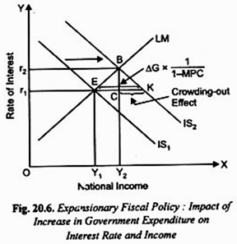](http://cdn.economicsdiscussion.net/wp-content/uploads/2015/08/image250.png)**

In the IS-LM model the increase in national income by Y1 Y2 in Fig. 20.6 is less than EK that would occur in Keynes’ model. This is because Keynes in his simple multiplier model assumes that investment is fixed and autonomous, whereas in IS-LM model Investment is a function of interest rate. So increase in Government expenditure crowds out some private investment.

Similarly it can be illustrated that the reduction in Government expenditure will cause a leftward shift in the IS curve, and given the LM curve unchanged, will lead to the fall in both rate of interest and level of income.

**Dynamics Of Adjustment-**

We assume that money market adjusts rapidly while goods market adjusts slowly. So initially when G increases, we are at point E and to the left of new IS curve. This means there is excess demand for goods, which will cause firms to increase output and income which raises the demand for money and rate of interest.

**Crowding Out**

Comparing E’ to E we see that increase in G raises both income and interest rate. But income does not increase by the full multiplier as increase in income leads to higher demand for money and increase in interest rate. Higher interest rate reduces investment spending therefore increase in government spending crowds out private spending leading to a smaller increase in income.

How much crowding out takes place depends on_

1. Slope of LM- The flatter the LM curve, the larger would be increase in income and smaller the increase in interest rate.
2. Slope of IS- the flatter the IS , the smaller would be the increase in income and interest rate.
3. The larger the multiplier αg the larger would be the increase in income and interest rate.

**TWO EXTREME CASES**

**1 Liquidity Trap**

**Crowding Out when LM is Horizontal— (Liquidity Trap Region) Keynes Approach:**

No crowding out takes place because the LM curve is horizontal.

**Reason of horizontal LM curve:**

In the liquidity trap region, any change in the monetary policy cannot affect the interest rate. The interest rate has fallen to such a low level, that is, the price of bonds are so high that people prefer to hold money in cash, that is, in liquid form. They believe that buying other assets e.g. bonds will lead to a capital loss. Therefore, LM curve becomes horizontal parallel to the x-axis. (Fig. 11.9)

In this region the monetary policy is totally ineffective but the fiscal policy is fully effective and therefore, when the Government spending increases, it has full multiplier effect on the equilibrium level of income but no effect on the interest rate. Since interest rate does not change, investment will not decrease and, thus, it will have no adverse effect on the income level.

**[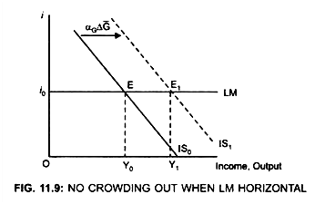](http://cdn.economicsdiscussion.net/wp-content/uploads/2014/12/image112.png)**

Due to an expansionary fiscal policy, IS curve shifts to the right from IS0 to IS, Income level increases from Y0 to Y1

∆Y = Y0Y1

As interest rate is unaffected, increase in income (∆Y) = αG∆G.

**2. Crowding Out When LM is Vertical—Classical Approach:**

**[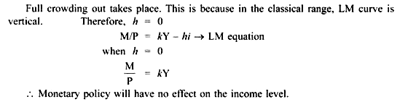](http://cdn.economicsdiscussion.net/wp-content/uploads/2014/12/image113.png)**

Though an increase in the Government spending will shift the IS curve to the right yet it will have no effect on the level of income; only the interest rate will increase. This is because when LM curve is vertical, the demand for money does not respond to changes in the interest rate.

**[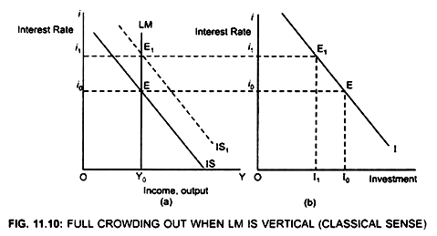](http://cdn.economicsdiscussion.net/wp-content/uploads/2014/12/image114.png)**

Initially the economy is in equilibrium at point E (Fig. 11.10).

Income level → Y0

i → i0

Investment → I0

Due to fiscal expansion IS curve will shift to the right to IS1.

The economy is in equilibrium at E1 but at a higher interest rate i1 and same income level Y0.

Due to an increase in the interest rate, cost of borrowing increases, therefore, Investment decrease from I0 to I1 which is equal to government spending.

Thus, an increase in the interest rate will crowd out private spending by an amount equal to the increase in the Government spending, that is, decrease in income = increase in the Government spending and there is full crowding out.

**Investment Subsidy**

**Assume the Government gives an Investment tax credit:**

Due to investment tax credit, the level of investment spending increases because a part of cost of investment is borne by the Government. Therefore, due to investment tax credit, the Investment curve will shift to the right from I to I1 (Fig. 11.14)

This shows that at a given interest rate (i0) firms will invest more.

**Result:**

AD will increase.

**[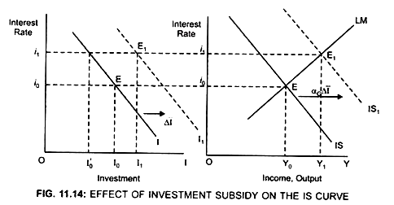](http://cdn.economicsdiscussion.net/wp-content/uploads/2014/12/image119.png)**

**[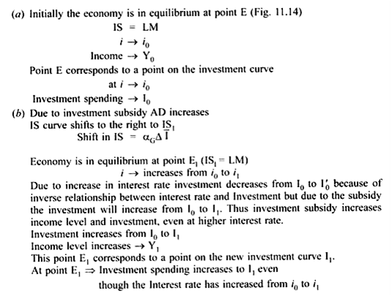](http://cdn.economicsdiscussion.net/wp-content/uploads/2014/12/image120.png)**

**Monetary Policy to Ensure Economic Stability: Explained through IS-IM Curve Model:**

Through making appropriate changes in monetary policy the Government can influence the level of economic activity. Monetary policy may be expansionary or contractionary depending on the prevailing economic situation. IS-LM model can be used to show the effect of expansionary and tight monetary policies. A change in money supply causes a shift in the LM curve; expansion in money supply shifts it to the right and decrease in money supply shifts it to the left.

Suppose the economy is in grip of recession, the Government (through its Central Bank) adopts the expansionary monetary policy to lift the economy out of recession. Thus, it takes measures to increase the money supply in the economy. The increase in money supply, Will shift the LM curve to the right and will lead to the fall in rate of interest. At a lower interest there will be more investment by businessmen. More investment will cause aggregate demand and income to rise. With expansion in money supply LM curve will shift to the right as is shown in Fig. 20.8. As a result, the economy will move from equilibrium point E to D and with this the rate of interest will fall from r1 to r2 and national income will increase from Y1 to Y2. Thus, IS-LM model shows that expansion in money supply lowers interest rate and raises income.

We have also indicated what is called **monetary transmission mechanism**, that is, how IS-LM curve model shows the expansion in money supply leads to the increase in aggregate demand for goods and services. We have thus seen that increase in money supply lowers the rate of interest which then stimulates more investment demand. Increase in investment demand through multiplier process leads to a greater increase in aggregate demand and national income.

**[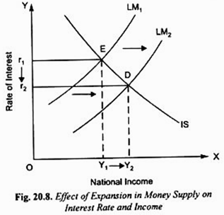](http://cdn.economicsdiscussion.net/wp-content/uploads/2015/08/image252.png)**

The Central Bank can adopt tight or contractionary monetary policy to control inflation through open market operations by selling bonds in the open market and in return get currency funds from those who buy the bonds. In this way liquidity in the banking system can be reduced.

With this money supply in the economy declines.

IS-LM model can be used to show that reduction in money supply will cause a leftward shift in LM curve and will lead to the rise in interest rate and fall in the level of income. The rise in interest rate which will cause reduction in investment demand and consumption demand and help in controlling inflation. This is shown in Fig. 20.9.

**[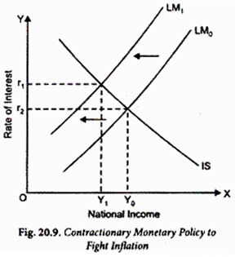](http://cdn.economicsdiscussion.net/wp-content/uploads/2015/08/image254.png)**

Transmission of changes in money supply, through open market operations, runs as follows:

1. In the first step increase in money supply following the expansionary monetary policy leads to the fall in rate of interest.

2.In the second step of transmission mechanism, fall in rate of interest causes increase in total spending or aggregate demand (especially, investment expenditure). Finally, the aggregate output adjusts to the changes in aggregate demand. However, some linkages in transmission process of the effect of changes in money supply may not work.

**Effectiveness of MONETARY POLICY**

#### Banks’ Reluctance to Lend:

The case when monetary policy has only limited effect on investment spending and therefore on real national income occurs when banks are reluctant to increase lending for investment in response to lower interest rate. This happened in the US in 1991 and then in 2008-09 and 2009-10, when global financial crisis occurred.

This situation also seems to have occurred in India in 2008-09 following the global financial crisis. In this case when the Central Bank of the US expanded money supply leading to lower interest rate, banks were reluctant to increase lending for the fear that lending might create bad loans with little possibility of being paid back.

**The Liquidity Trap**

Liquidity trap refers to a situation in which an increase in the money supply does not result in a fall in the interest rate but merely in an addition to idle balances: the interest elasticity of demand for money becomes infinite. Under normal conditions an increase in money supply, resulting in excess cash balances, would cause an increase in bond prices, as individuals sought to acquire assets in exchange for money, and a corresponding fall in interest rates.

In such a situation, described by Keynes as liquidity trap, individuals believe that bond prices are too high and will therefore fall, and correspondingly that interest rates are too low and must rise They, therefore, believe that to buy bonds would be to incur a capital loss and as a result they hold only money. This means that an increase in the money supply merely increases idle balances and leaves the interest rate unaffected.

The implication here is that any attempt to achieve the internal expansion through increased investment brought about by lowering the interest rates would fall, because any increase in the money supply created in order to reduce the rate of interest would be held in the form of cash balances, making it impossible to use interest rates (monetary policy) to expand the economy. See Fig. 7 which describes such a situation.

**[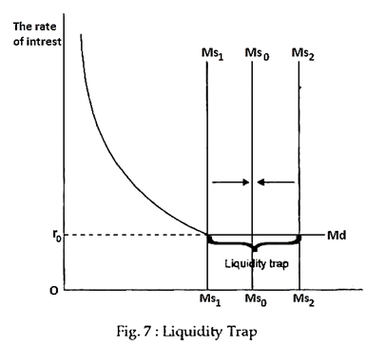](http://cdn.economicsdiscussion.net/wp-content/uploads/2016/12/image-44.png)**

**The Classical Case :**

On the other hand, if the LM curve is vertical, monetary policy is highly effective because the demand for money is perfectly interest inelastic. Figure 4 shows that when the vertical LM curve shifts to the right to LM with the Increase in the money supply, the interest rate falls from OR to OR1which has no effect on the demand for money and the entire increase in the money supply has the effect of raising the income level from OY to OY1.

